Core Concepts and Key Insights
Disaster Recovery (DR) Types:
  - Planned DR: Controlled failover before a known event (e.g., storm). No data loss expected; downtime is managed.
  - Unplanned DR: Sudden failure or disaster causing data loss and extended downtime due to lack of preparation.
  - Testing DR: Regular drills to ensure failover processes work and to build confidence in DR readiness.
Human Errors and Automation:
  - Humans are often the cause of failures (misconfigurations, bad deployments).
  - Direct human access to production should be minimized.
  - Use automation, orchestration, and CI/CD pipelines with version control and approval gates to reduce human errors.
  - Implement progressive deployment patterns (canary releases, rings, blue-green deployments) to limit blast radius of failures.
  - Blue-Green Deployment: Maintains two identical production environments ("Blue" for current, "Green" for new). The new version is deployed to the idle environment and tested. Traffic is switched instantly via a load balancer. It offers instant, simple rollbacks.
  - Canary Releases: A new version is released to a small, subset of users (the "canary") to monitor performance before expanding to the full audience. It is a highly risk-averse, incremental approach.
  - Ring Deployments (or Ring-based deployment): A form of progressive delivery where the release is rolled out in stages, or "rings" of users. For example, Ring 0 might be internal developers, Ring 1 early adopters, and Ring 2 the general public.
Stateful vs Stateless Components:
  - Stateless components “do stuff” without maintaining important state; easy to replicate and scale.
  - Stateful components “remember stuff” (e.g., databases, file shares) and require replication and backup strategies.
  - Design architectures to isolate state in as few components as possible to simplify resiliency efforts.
Replication and Backup:
  - Replication maintains copies of data/services in near real-time but may propagate logical corruption or ransomware.
  - Backups provide point-in-time recovery, stored offsite or isolated to protect against corruption and attacks.
  - Use snapshots for local quick rollback; backups for long-term retention and geographic isolation.
Recovery Objectives:
  - Recovery Time Objective (RTO): Maximum acceptable downtime.
  - Recovery Point Objective (RPO): Maximum acceptable data loss.
  - Tighter RTO/RPO increases complexity and cost.
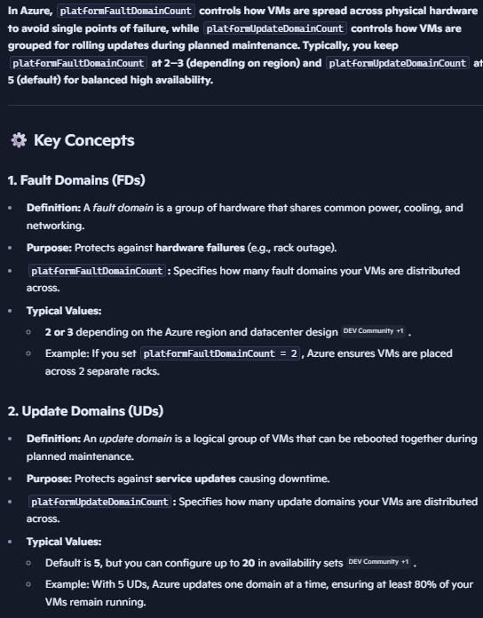
Azure resiliency constructs:
  - Fault Domain(FD): Physical rack-level isolation. If rack has failure, everything in rack will fail.
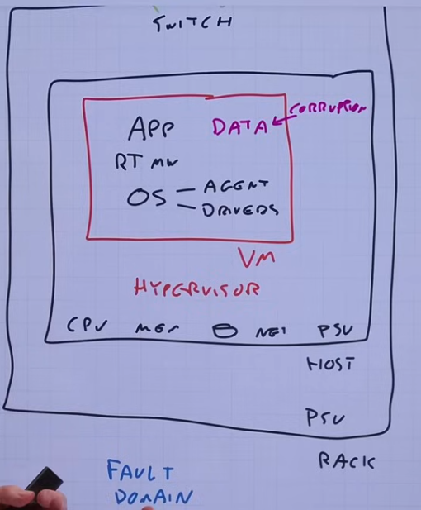
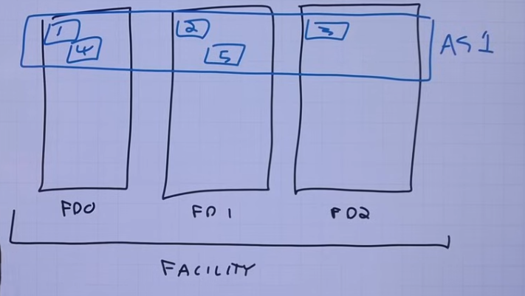
  - Availability Set(AS): 99.95 % SLA. Distributes VMs across fault domains; minimum two instances needed to gain any resilience benefit. If entire rack (fault domain) goes down, workload still runs. Racks are in a single facility (or data center). We can’t mix workloads in availability set and should create separate AS for every unique workload like domain controller, database, web server etc, so they any 1 workload type doesnt end up in same rack when single AS is used and round robin assigns them to FD in AS. Each workload must have presence in all FDs in AS, to be any useful.

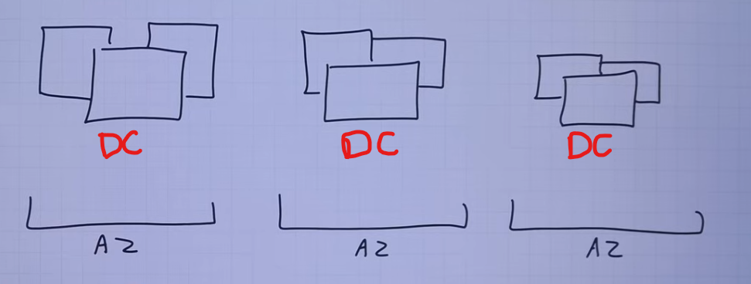
  - Availability Zone: Physically separate set of datacenters within a region; protects against datacenter-level failures; higher SLA (99.99%). not every region has AZs. Each set of datacenters is a zone, in a region. There is no guarantee of fixed distance b/w them, but 2ms latency is promised in a region. Each has independent power, cooling, n/w. Each region supporting AZ has 3 AZ. Serial number of AZ is random and varies across subscriptions, to avoid concentration of resources in any 1 AZ. So AZ1 in sub1 might not correspond to same datacenter as AZ1 in sub2, in same region.
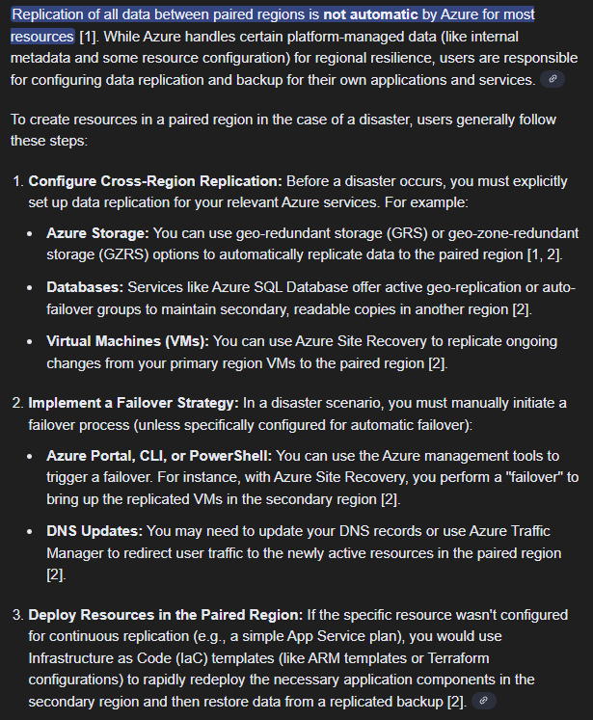
  - Region: Geographic separation; used for disaster recovery and geo-redundancy. Avoid single points of failure by distributing workloads across these boundaries. Most regions have pairs like east-us->west-us, east-us2->central-us, where data might be replicated for few services. Using many regions instead of paired regions is preferable as in case of failure, everyone else will also be relying on paired region only, so will be bottlenecked.
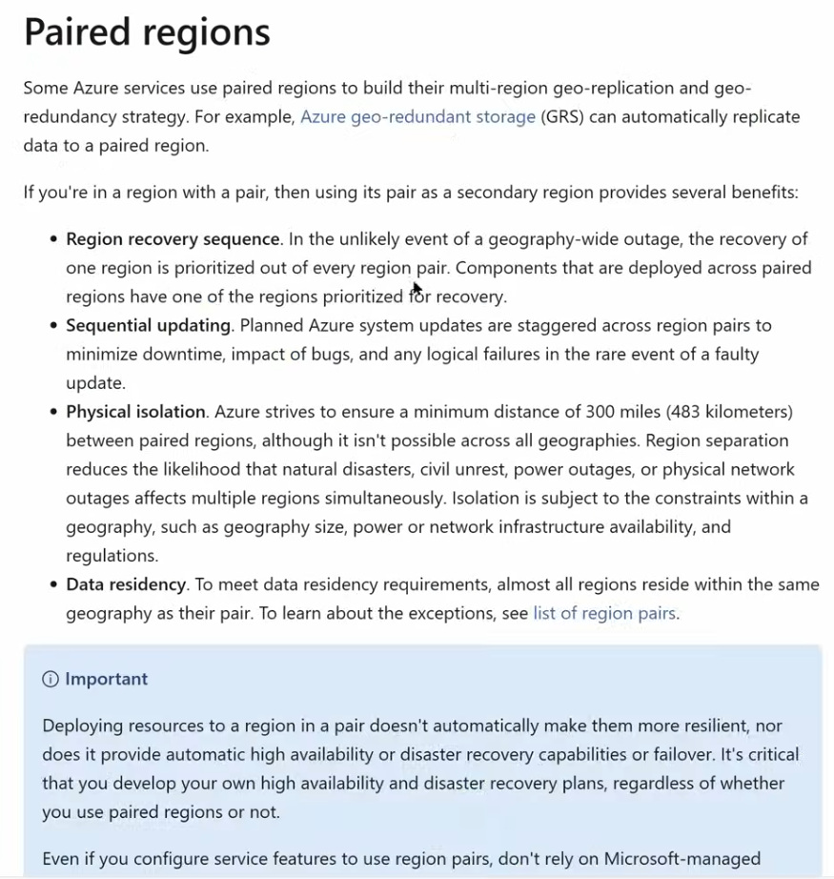

**Proximity placement group is not resiliency feature. It is used when super low latency is required so distance is very low, therefore not resilient.
Replication Types:
  - Synchronous Replication: example - Within region, commits to primary and replica DB together before acknowledging to the application; no data loss risk but may impact performance.
  - Asynchronous Replication: Between regions, primary acknowledges before replica commit; risk of data loss on failover (RPO) but minimal impact on performance.
- Service Level Agreements (SLAs):
  - SLAs vary per Azure service and affect architecture.
  - Composite SLA depends on dependencies: “AND” relationships reduce overall SLA, “OR” relationships improve it. Higher availability costs more; balance business needs and budget.

Many services like Entra ID, DNS zones are global and resilient against any regional failure. Most resources are deployed to a region with many options available: Regional(deployed anywhere in region), Zone redundant (distributed over multiple AZs), Zonal (deployed to specific AZ user specifies), locally redundant (3 copies in same AZ). Some resources like public IPs are locked to a region and cant move b/w them. NAT gateway is zonal and cant span across zones – but vnet can span zones in a region, so if a nat gateway is used, it acts as a single point of failure for resources even spanning zones, unless resources are alligned logically to specific separate vnets for each zone and zone specific nat gateway.
- Multi-region and Multi-instance Architecture:
  - Use multiple regions (atleast 2) for true resiliency and disaster recovery.
  - Consider active-active versus active-passive app architecture models depending on application and data requirements. Active-active setups, where all nodes process traffic simultaneously, provide maximum resiliency, near-zero downtime, and high performance. Active-passive relies on a standby node that only takes over during a failure, offering simpler, lower-cost management but at the expense of potential downtime during switchover. In active-active case with replica across regions, we ideally want to have only one replica (primary) where write is performed to avoid inconsistencies and conflicts. Read can be done from both. If we want active-active with multi write, we want consistency in a session, so users see same in both places. NoSQL databases (e.g., Cosmos DB) offer multi-region active-active with session consistency(ensure consistency for a session) or eventual (eventually both copies become consistent), unlike relational databases which are generally active-passive due to ACID constraints.
Eventual consistency is a weak consistency model, commonly used by many NoSQL databases (like Cassandra and CouchDB) in the cloud to achieve high availability and scalability. How it Works: When a write occurs on one database replica, that change is not immediately propagated to all other replicas. Instead, the system guarantees that if no new updates are made to that data item, eventually, all accesses to that item will return the last written value. Pros in Cloud Scenarios: It provides low latency and high throughput, making it ideal for globally distributed applications (e.g., social media feeds, e-commerce shopping carts) where some brief data inconsistency is acceptable. Cons: Reads immediately following a write may return stale data from a replica that has not yet received the update.
NoSQL vs. SQL: NoSQL databases often prioritize performance and availability over immediate consistency, making eventual consistency their default or a common option.
Session Consistency
Session consistency is a hybrid consistency model that strengthens eventual consistency by guaranteeing that a client within a specific "session" will always read the data it has written, even if those writes haven't propagated globally yet. How it Works: The system ensures that all subsequent reads within the same session are routed to a data replica that contains the client's most recent writes. Outside of that specific session, other users may still see the older data until the changes are fully propagated. Pros in Cloud Scenarios: It offers a practical balance for user-centric applications (e.g., user profile updates), where the individual user needs a consistent view of their own actions, while global consistency can be delayed. Cons: It can be slightly more complex to implement and manage than simple eventual consistency.
NoSQL vs. SQL: Some modern NoSQL systems offer session consistency as an optional feature.
Consistency in SQL Databases
SQL databases (e.g., PostgreSQL, MySQL), traditionally designed around the ACID (Atomicity, Consistency, Isolation, Durability) properties, usually default to stronger consistency models like strong consistency or serializability. Strong Consistency: Guarantees that any read operation will always see the most recently written data, no matter which node it connects to. This ensures data accuracy but can introduce higher latency and lower availability in distributed cloud environments compared to weaker models. SQL databases prioritize data integrity and consistency, making them the preferred choice for transactional systems like banking or order processing, where data must always be accurate.

- Monitoring and Observability:
  - Implement comprehensive monitoring and synthetic transactions to detect issues in end-to-end workflows, not just individual components. Use anomaly detection to catch performance or behavioral deviations early.
- Azure Site Recovery (ASR):
  - Provides VM replication for on-premises Hyper-V, VMware, physical servers, and Azure VMs. eg. Hyperv-v vm .vhdx file is replicated to azure storage as .vhd, every few second/minutes, so only storage cost is paid. Only during failover vm is launched, and compute cost suffered.
Can also be used to replicate azure VM across regions, or to another AZ in same region.
  - Supports crash-consistent and app-consistent snapshots.
  - Enables orchestrated failover and failback with automation via recovery plans.
- Backup Strategies in Azure:
  - Azure Backup uses Recovery Services Vaults and Backup Vaults depending on workloads.
  - Supports granular retention policies (daily, weekly, monthly, yearly).
  - Offers soft delete (purged after 14 days) and always-on soft delete protections to prevent accidental or malicious backup deletion. Recovery service vault cant be deleted if it is registered to a server (need to stop the backup) and holds backup data.
  - Introduces multi-user authorization for critical backup operations using a separate Resource Guard (in different tenant/subscription created by security admin) and privileged identity management, so regular backup admin (having basic permission on backup vault) is not able to manage resource guard without special permissions.
  - Supports immutable vaults to enforce write-once-read-many (WORM) policies for tamper-proof backups.
- Clustered Workloads in Azure:
  - Use Distributed Network Names (DNN) in Windows Server 2019+ to avoid shared IP failover challenges.
  - Prefer Always On Availability Groups over shared storage clusters to reduce single points of failure.
  - Use Cloud Witness for quorum in multi-region clusters.

Definitions and Comparisons
Term | Definition/Description
Planned DR | Failover initiated before a disaster with no expected data loss or unexpected downtime.
Unplanned DR | Failover due to unexpected disaster, potential data loss and extended downtime.
Fault Domain | Physical rack in data center; failure isolates to that rack.
Availability Set | Azure construct to distribute VMs across fault domains to avoid single rack failure.
Availability Zone (AZ) | Physically separate datacenters within a region, offering higher SLA and isolation.
Recovery Time Objective (RTO) | Maximum allowable downtime after a disaster.
Recovery Point Objective (RPO) | Maximum tolerable data loss in terms of time.
Synchronous Replication | Data writes completed on primary and replica before acknowledgment; no data loss risk, higher latency.
Asynchronous Replication | Primary acknowledges write before replica; lower latency but possible data loss on failover.
Soft Delete | Backup retention feature to protect against accidental or malicious deletion by retaining deleted backups for a grace period.
Immutable Vault | Backup storage that cannot be deleted or altered during locked retention period, ensuring tamper-proof backups.
Distributed Network Name (DNN) | Cluster feature in Windows Server 2019+ for load balancing without shared IP; improves failover.

Best Practices Highlighted
- Design applications to be stateless where possible; isolate stateful components.
- Use multiple fault domains, availability zones, and regions for fault isolation.
- Define realistic RTO, RPO, and SLA targets based on business requirements.
- Implement automated deployment pipelines with testing and progressive rollouts.
- Use synthetic transactions and monitoring to detect failures proactively.
- Protect backups with multi-user authorization, soft delete, and immutability.
- Avoid single points of failure, including dependencies on global services like Entra ID.
- Use Azure Site Recovery for VM replication and orchestrated failover.
- Prefer Always On Availability Groups over shared storage clusters in Azure.
- Maintain version control and infrastructure-as-code for all configurations and deployments.
- Regularly perform DR testing and chaos engineering to validate resiliency.

Key Azure Services and Features Mentioned
Service/Feature | Purpose/Role
Azure Availability Sets | Distribute VMs across racks to reduce impact of rack-level failures.
Azure Availability Zones | Physically isolated datacenters within a region for higher resiliency.
Azure Regions | Geographically separate locations for disaster recovery and geo-redundancy.
Azure Site Recovery (ASR) | VM replication and failover orchestration for (on-premises or Azure VMs), to Azure.
Azure Backup | Backup solution with retention policies, soft delete, immutable vaults, and multi-user auth.
Azure Traffic Manager | DNS-based global traffic load balancing.
Azure Front Door | Layer 7 global load balancing with caching and health checks.
Azure Kubernetes Service (AKS) | Supports zone redundancy for container orchestration.
Azure Resource Manager (ARM) | Infrastructure-as-code and deployment automation.
Azure Monitor & Application Insights | Observability and monitoring of applications and infrastructure.
Azure Managed Identities | Secure service-to-service authentication without storing credentials.

Important Considerations
- Latency matters greatly in replication; synchronous replication works within regions, asynchronous between regions due to speed-of-light delays.
- Backup isolation is critical: backup permissions and storage must be separate from production to protect against attacks.
- Cost vs resilience trade-off: Higher availability and lower RTO/RPO increase complexity and cost exponentially.
- Automated failover and failback reduce human error and speed recovery.
- Understanding dependencies between components (e.g., app tiers, identity services, storage) is essential for holistic resiliency.
- Regular DR testing and chaos engineering uncover hidden weaknesses and validate recovery plans.
- Multi-region active-active architectures require application-level consistency models and conflict resolution strategies.

